PID Controller Design Project

Controller Implementation:

(1). Body rate controller:

This is a P controller. The inputs are errors between the target and the actual rate of three Euler angles. The outputs are torques on three body frame axes.

(2). Roll pitch controller

The controller accepts the target acceleration in global frame, the actual attitude and the desired collective thrust. The outputs of the controller are the desired roll and pitch rate.

(3). Altitude controller

This is a typical PID controller. It accepts the target altitude then compute the thrust that will move the drone to the desired position.

(4). Lateral position control

The controller accepts the target and the actual lateral position and velocity. The outputs are the acceleration in two lateral directions.

(5). Yaw controller

Since Yaw motion is a first order system, we just use P controller to correct the yaw angle.

Flight evaluation:

Scenario 2:

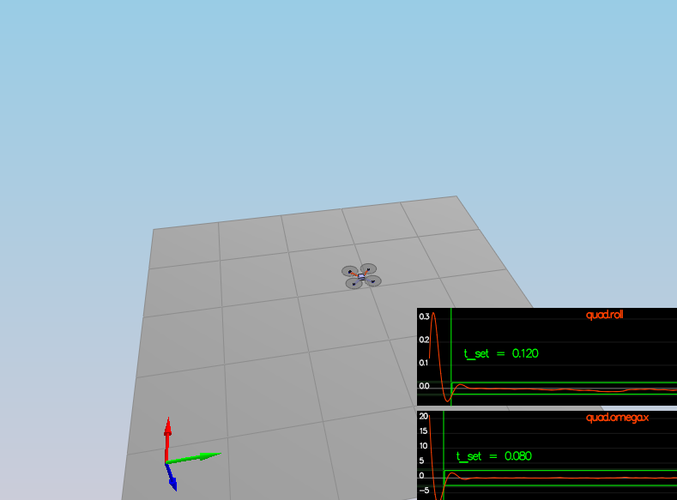

Scenario 3:

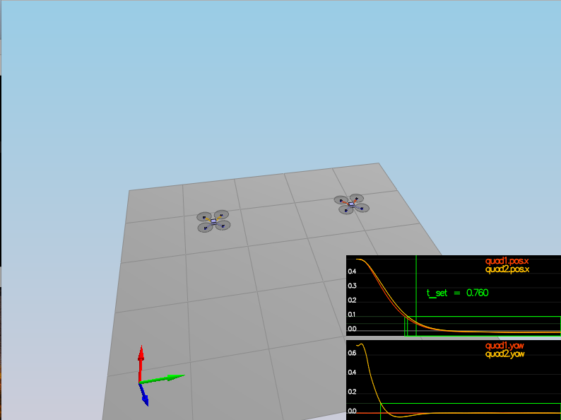

Scenario 4:

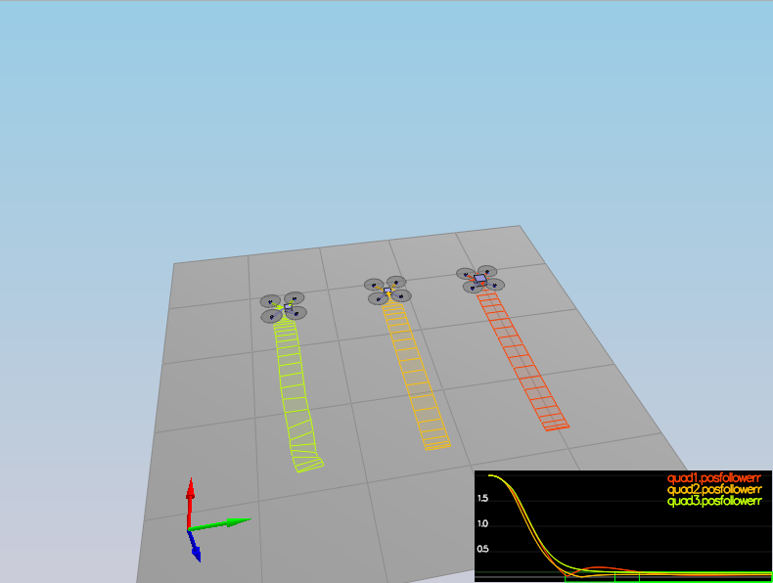

Scenario 5:

